Stu

YEAR 12 CHEMISTRY

TEST 6 2010

Organic Chemistry

PART 1: Multiple choice section (15 marks)
Please do not mark this question booklet in any way. Put your answers on the answer sheet provided

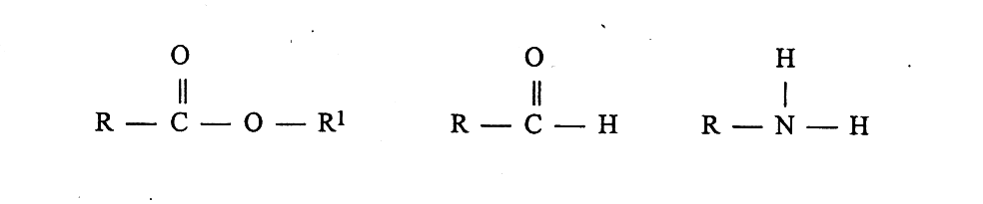
1. Which list correctly names the functional groups shown? R and R¹ represent alkyl
groups.

- ester aldehyde nitro

- carboxylic acid ketone amino

- carboxylic acid ketone amine

- ester aldehyde amine

2. Which of the following compounds readily undergoes addition reactions?

(a) ethane

(b) benzene

(c) propene

- ethanol

3. What is the systematic name for the compound CH3CH2CH(CH3)CH2CH2Br using the IUPAC system?
(a) 2-bromoethylbutane

(b) 3-methyl-5-bromopentane

(c) 1-bromo-3-methylpentane

(d) 1-bromo-3-ethylbutane

4. Which one of the following compounds has the highest boiling point temperature?

(a) C3H8

(b) C2H5COOH

(c) C2H5OH

- C2H5CHO

5. Which of the following pairs of monomers would most readily produce a condensation polymer?

(a) HOOC(CH2)2COOH and HO(CH2)2OH

(b) C2H4 and C3H6

(c) C2H5COOH and C2H5OH

(d) CH3COOH and NaOH

6. A functional group is best described as:

(a) the non-polar section in an organic molecule.

(b) a highly reactive group of elements with similar outer shell electron configuration.

(c) an atom or group of atoms which determines the chemical properties of a compound.

a carbon - carbon bond in an organic molecule

7. The compound CH₃CH₂CH₂COOCH₃ is a component of pineapple fragrance.
The systematic name of this compound is:

(a) propyl ethanoate.

(b) butyl methanoate.

(c) methyl propanoate.

- methyl butanoate.

8. Consider the structures A and B.
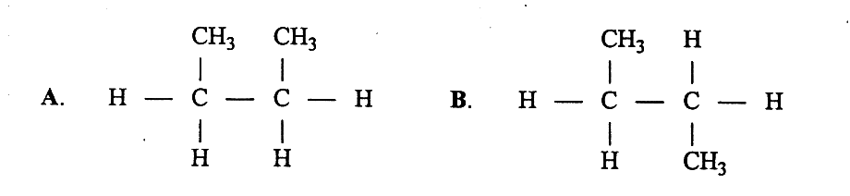

Which of the following statements is correct concerning these structures?

- A and B are geometric isomers with A being the cis isomer.

- A and B are structural isomers.

- A and B show both structural and geometric isomerism.

- A and B represent the same compound.

9. When 1− butene is reacted with hydrogen chloride gas, the product (s) is/are:

- 1−chlorobutane

- 2−chlorobutane

- 1−chlorobutane and hydrogen gas

- 2−chlorobutane and hydrogen gas

10. Which of the following compounds will exhibit hydrogen bonding between
neighbouring molecules of the same substance?
I propanol
II propanone
III propanal
IV propanoic acid
V propyl propanoate
(a) I, II and III
(b) II, III and IV
(c) I and IV
(d) V only

11. Which of the following statements best indicates the way in which a modern
detergent cleans a greasy plate?

(a) The detergent molecules contain hydroxyl groups (-OH) and remove the
layer of grease from the plate by forming strong hydrogen bonds directly
with the polar grease molecules.

(b) The detergent molecules are non-polar and are therefore able to attract
the non-polar grease molecules with dispersion forces.

(c) The detergent molecules have one end which is non-polar, and attaches
to the grease molecules with dispersion force, while the other polar end
attaches itself to the polar water molecules by dipole-dipole interactions.

(d) The detergent molecules react with water to form a weak acid, which is
then able to dissolve the grease molecules.

12. Which of the following are isomeric with pentane (CH₃-CH₂-CH₂-CH₂-CH₃)?
(a)

(b) 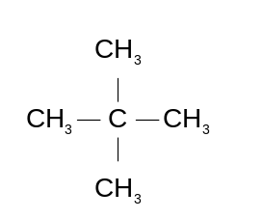
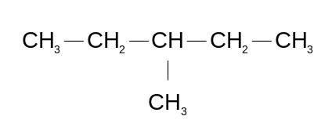

(c)
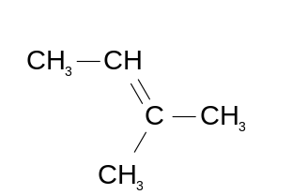

(d)
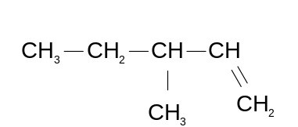

13. What is the name given to the type of reaction that can occur between bromine and
ethane?

(a) esterification

(b) polymerisation

(c) substitution

(d) addition

14. Which of the following are tertiary alcohols?
I  H₂C –– CH₂  | |  H₂C –– C –– OH  |  CH₃ | II  CH₃CH₂CH₂OH
III  (CH₃)₃COH | IV  CH₂ –– OH  |  CH –– OH  |  CH₂ –– OH

(a) II and IV only
(b) I and III only
(c) I and IV only
(d) II and III only

15. Choose the correct statement for these two organic structures.

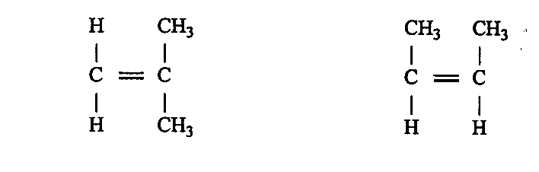

- they show the same compound C₄H₈.

- they show the compound 1,1 − dimethylethene.

- they show a pair of cis-trans isomers.

- they show a pair of structural isomers.

END of PART 1, go on to PART 2

Chemistry Test 6: Organic Chemistry 2010

Student Name: Class Code:

Lecturers Name: Adelfo / Grant / John / Ken / Owen / Steve
(Please circle your lecturer’s name)

Mark your answer with a cross (X) through the correct letter.

Part 1 Multiple Choice (15 marks)

1 | (a) | (b) | (c) | (d) |  | 9 | (a) | (b) | (c) | (d)
2 | (a) | (b) | (c) | (d) |  | 10 | (a) | (b) | (c) | (d)
3 | (a) | (b) | (c) | (d) |  | 11 | (a) | (b) | (c) | (d)
4 | (a) | (b) | (c) | (d) |  | 12 | (a) | (b) | (c) | (d)
5 | (a) | (b) | (c) | (d) |  | 13 | (a) | (b) | (c) | (d)
6 | (a) | (b) | (c) | (d) |  | 14 | (a) | (b) | (c) | (d)
7 | (a) | (b) | (c) | (d) |  | 15 | (a) | (b) | (c) | (d)
8 | (a) | (b) | (c) | (d)

Part 2: Short answer questions (35 marks)
Answer questions on this sheet in the spaces provided.
1. Write balanced equations for the reactions which occur in the following experiments. Use ionic equations where appropriate. In each case give all observations.
a) Acidified potassium dichromate is added to 2−propanol
Oxidation half equation

Reduction half equation

Redox equation

Observation

_______________________________________________________________
(4 marks)
b) Ethane gas and excess bromine water is mixed in a sealed container and the
mixture exposed to ultraviolet light until the reaction is complete.
Equation

Observation

___________
(2 marks)
c) Explain how you could distinguish between cyclohexane and cyclohexene. Write the
observation and the equation that would distinguish between them.
Observation
________________________________________________________________
________________________________________________________________
Equation
________________________________________________________________
(2 marks)
d) Ethanoic acid, 1−propanol and sulphuric acid are gently heated
Equation
________________________________________________________________
Observation
________________________________________________________________
________________________________________________________________
(2 marks)
2. Draw the structural formulas for all the isomers of the molecular formula C₂H₂ClBr

(2 marks)

3. Give the IUPAC name for the substances having the following condensed structural formulas.
a) CH₃CH₂COOCH₂CH₂CH₃ ______________________________

b) CH₃CH₂CH₂NH₂ ______________________________

c) CH₃CH₂CH₂CH₂CH₂COOH ______________________________

d) CH₃CH₂COCH₂CH₃ ______________________________

e) CH₃CHO ______________________________

f) CH₃CH₂CH(OH)CH₂CH₃ ______________________________
(6 marks)

4. Draw the structural formulas (showing all hydrogen atoms) and give the IUPAC names for the following:
a) an −amino acid containing four carbon atoms per molecule
Name ______________________________________________

b) a primary amine containing 9 hydrogen atoms
Name ______________________________________________

(4 marks)

5. Draw structural formula for the following compounds.
a) propyl ethanoate b) 3−methylpentanal

c) trans-1,4-dichloro-2-butene d) cyclohexene

(4 marks)
6. The structures and melting points are provided for two similarly sized organic
substances. Explain the difference in their melting points.
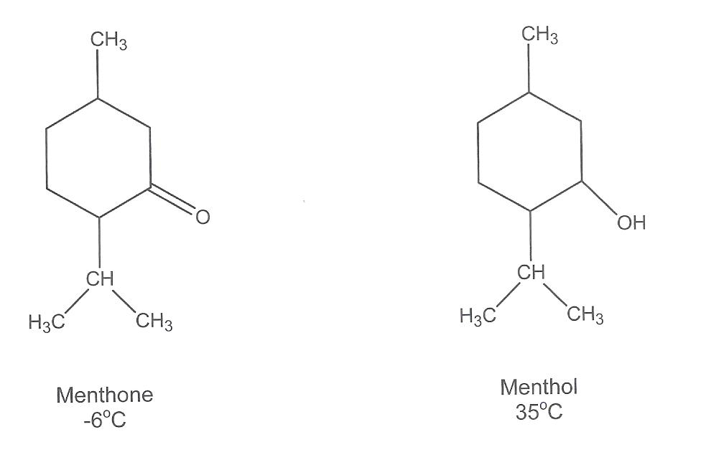

(2 marks)
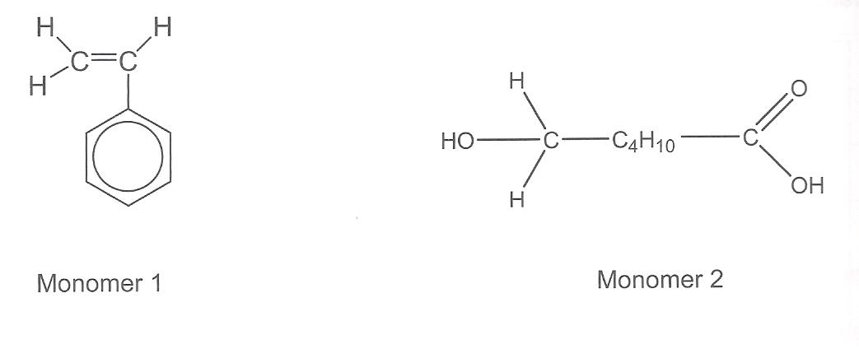
7. Below are the structural formulas of two monomers that can be used to produce
polymers.

a) Which one of the two monomers can be used to produce an addition polymer?

Answer: __________________ (1 mark)
b) Draw a diagram of the addition polymer that would result from your choice. You must
show at least two repeating units in the box below.

(1 mark)

8. Calculation
All working should be shown for the calculations. Marks are awarded for working and setting out as well as final answers.

An organic compound containing only carbon, hydrogen and oxygen is analysed by combusting a 3.605 g sample in excess oxygen. All the carbon in the compound is converted to carbon dioxide, and all the hydrogen it contains is converted to water.

(a) Given that the mass of carbon dioxide produced is 8.802 g and the mass of water is 3.603 g, calculate the empirical formula of the compound.
(2 marks)
(b) When a 1.234 g sample of the compound is vaporised in the absence of air, the vapour occupies 441.8 mL at 22.0oC and 95.0 kPa. From this data, calculate the molecular formula of the compound.
(2 marks)
(c) Further analysis shows the compound is an aldehyde. From this information, draw the structural formula of the compound and then give the molecule a systematic name.
(1 mark)

END OF TEST Total 50 marks

